**Wood Panel Wallpaper in Olive Green**

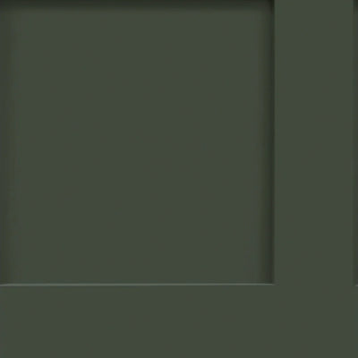Wood panel wallpaper in olive green brings a fresh, earthy vibe to any space, blending the timeless appeal of wood with the soothing, organic tone of green. The rich olive shade creates a grounding, natural atmosphere, perfect for adding warmth and depth to interiors while maintaining a sense of tranquility. Ideal for spaces that seek a balance between modern design and nature-inspired elements, this wallpaper pairs well with neutral tones, natural materials, and vibrant accents. Whether used in living rooms, kitchens, or bedrooms, the olive green wood panel wallpaper creates a serene yet stylish backdrop that brings the outdoors inside.